Deworm Cattle for Better Health and Performance

Parasite management should be a key component of any cattle health program. Internal parasites affect feed intake and nutrient absorption. This results in lower average daily gain, poorer immune response to vaccines and diseases, lower reproductive performance and decreased milk production.

Merck Animal Health maintains the world’s largest database to monitor field use efficacy of dewormers approved for use in U.S. cattle. If you’re only using an endectocide, such as ivermectin, you may only be getting half of the reduction in worms necessary for effective deworming. The database¹ shows when using SAFE-GUARD® (fenbendazole), nearly 100% efficacy was obtained.

Several convenient formulations

Using feed and mineral forms of SAFE-GUARD – such as range cubes, dewormer blocks or mineral – require relatively little time and labor and are highly effective.
They are easy to use – especially when cattle are on pasture and are not located near working facilities. The cattle will come to it, and a successful deworming can be achieved in a very efficient manner.

One benefit of the SAFE-GUARD feed and mineral formulations is they allow deworming of cattle at the correct time or strategic time versus just when cattle are gathered.

Deworm cattle at the right time

Work with your veterinarian and schedule deworming based on your operation type and location, as well as the parasite life cycle. Doing so reduces the parasite burden both in your herd and on the pasture.

Don’t forget about the calves at cow side. At about six to eight weeks of age, calves start ruminating and are at high risk of internal worms. It is important to deworm them at the appropriate time. Deworming at early stages of infection can result in improved weaning weights. For spring-calving herds, it typically is good to deworm calves six to eight weeks after turnout onto pasture.

SAFE-GUARD dewormer works fast

SAFE-GUARD works differently than other dewormers. It goes straight to the gut. It features broad-spectrum activity against internal parasites. Parasites can’t excrete fenbendazole, the active ingredient in SAFE-GUARD. This means even cattle that ingest small amounts of SAFE-GUARD feed products over the course of a few feedings quickly build up to a lethal dose for any parasites that might be present.

We often think we can see an animal with parasites, but the visual difference is often minimal.
It is important to work with your veterinarian to set up a parasite management program that is best for your operation. Your veterinarian will know your goals and the health challenges in your area, so having a good relationship with them is important.

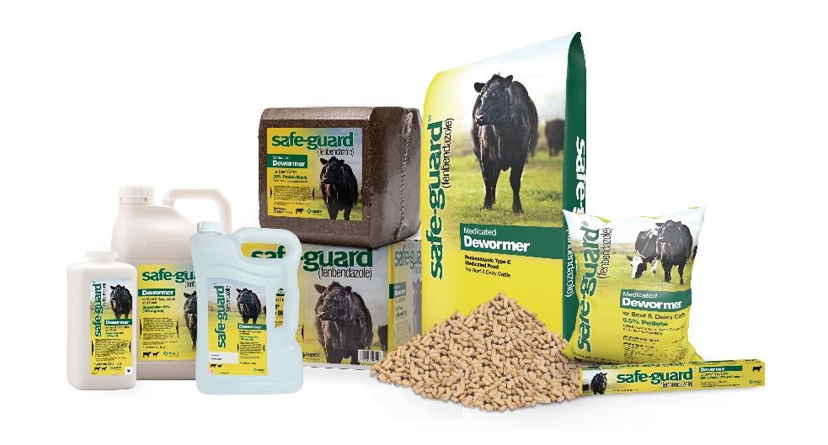
Photo caption: Parasite control should be the cornerstone of an animal health program because parasites negatively impact the overall health and performance of cattle. There are many formulations of SAFE-GUARD® available, including feed and mineral forms, that require relatively little time and labor and are highly effective.

¹Merck Animal Health maintains the world’s largest FECRT database to monitor field use efficacy of anthelmintic classes. Through 2018, there were 24,186 samples analyzed – 12,171 pre-treatment and 12,015 post-treatment.

IMPORTANT SAFETY INFORMATION: Do not use in beef calves less than 2 months old, dairy calves and veal calves. A withdrawal period has not been established for this product in pre-ruminating calves. Additionally, the following meat withdrawal and milk discard times apply: SAFE-GUARD Paste: Cattle must not be slaughtered for 8 days. For dairy cattle, the milk discard time is 96 hours. SAFE-GUARD Suspension: Cattle must not be slaughtered for 8 days. For dairy cattle, the milk discard time is 48 hours. SAFE-GUARD EN-PRO-AL® Type C Medicated Block: Cattle must not be slaughtered for 11 days. For use in beef cattle only. SAFE-GUARD 20% Protein Type C Medicated Block: Cattle must not be slaughtered for 16 days. For use in beef cattle only. SAFE-GUARD Type A and other medicated feed products (pellets, cubes, free-choice mineral, or free-choice liquid): Cattle must not be slaughtered for 13 days. For dairy cattle, the milk discard time is 60 hours.

© 2022 Merck & Co., Inc., Rahway, NJ, USA and its affiliates. All rights reserved.

