Spring Health Strategies that Pave the Way for Success

Spring is a critical season. Your herd health decisions during this time can make a major difference in calf health and weight gain, as well as impact the reproductive success of your cows. Consider these herd health suggestions this spring:

- Work with your veterinarian to build a herd health plan

Work with your veterinarian to develop a plan specific to your herd. Your veterinarian is an expert in identifying what pathogens and disease challenges are most problematic in your area. For calves, plans should focus on preventing respiratory disease and building strong immunity. For cows and bulls, the focus should be on reproductive health.

- Vaccinate calves to protect against disease

Spring is often your first opportunity to prime a calf’s immune system. A calf is born with a developing, however, immature immune system. An effective vaccination protocol can help prepare that immune system for periods where they are more vulnerable to respiratory disease like summer pneumonia or post-weaning pneumonia. That protocol should include vaccinating against common viruses like:

- Infectious Bovine Rhinotracheitis (IBR)
- Bovine Viral Diarrhea (BVD)
- Bovine Respiratory Syncytial Virus (BRSV)
- Parainfluenza3 virus (PI₃)

Producers also should guard against common bacterial causes of pneumonia, such as Mannheimia haemolytica and Pasteurella multocida.

Intranasal vaccines like BOVILIS® NASALGEN® 3-PMH and BOVILIS® NASALGEN® 3 have shown to be effective for the vaccination of healthy cattle 1 week of age or older. The vaccines provide protection against critical BRD-causing pathogens.

- Consider spring vaccination of cows

Spring vaccination of cows also should be considered whenever possible. Ask your veterinarian for advice as to whether this is an option for your herd. Vaccinating cows before breeding can protect against pathogens that can interfere with conception or cause abortions.

BOVILIS® VISTA® 5 VL5 SQ CFP is an example of a product that is shown effective against the common pathogens that cause respiratory disease, fetal infection and pregnancy loss, and reproductive disease, such as IBR, BVD Types 1 & 2, campylobacter fetus (vibrio) and leptospirosis.

- Eliminate internal parasites

Deworm cattle at turnout if not dewormed in the fall after a hard freeze. Strategic deworming cattle 4-6 weeks after pasture turnout does not require gathering and processing cattle. Using feed and mineral forms of fenbendazole – such as range cubes, dewormer blocks or mineral – requires relatively little time and labor and can be highly effective.

- Control pinkeye

Pinkeye is another major health challenge for cattle producers. Not only does pinkeye cause painful inflammation and lacerations, but it can also be costly to treat and can reduce weaning weight. A solid pinkeye management program should consider how to limit exposure to elements that can damage the corneal surface and incorporate the three primary tools of controlling pinkeye: vaccination, fly control and environmental management.

- Consider implanting calves at spring working

Growth implants have been extensively studied for decades. Implanting suckling calves at spring working can significantly enhance average daily gain between branding and weaning, resulting in more saleable weight in the fall.

- Document your steps

PrimeVAC™ by Merck Animal Health is an example of a value-added program that focuses on respiratory and clostridial vaccinations, as well as protection against internal parasites. It also includes optional implant protocols. It gives a clear guide of the steps needed to give calves the best start.

To learn more about Merck Animal Health cattle vaccines and protocols and how they can help you produce healthier, higher-value calves, contact your veterinarian and visit MAHcattle.com.

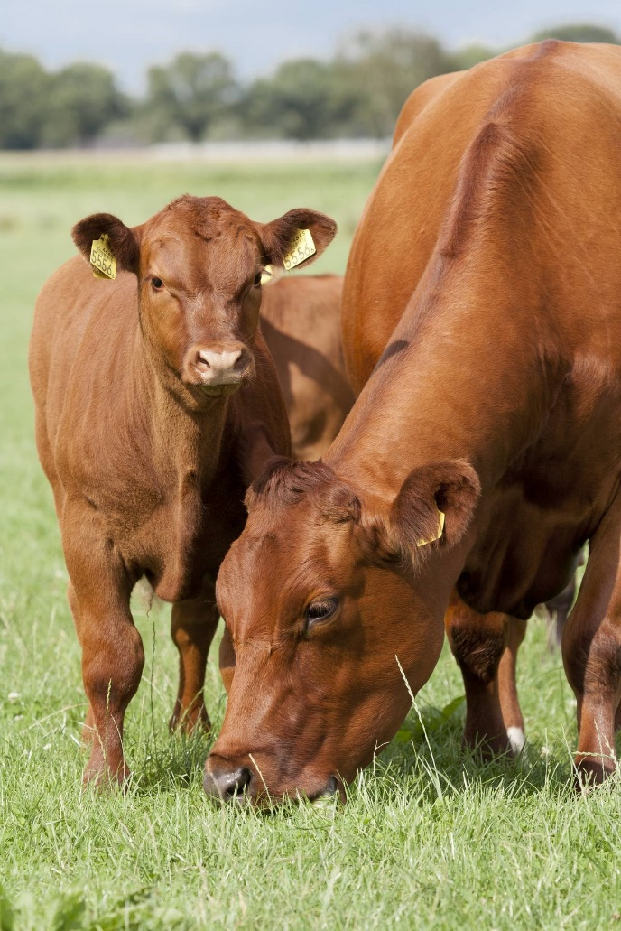
Photo caption: Keeping calves healthy and getting cows rebred are universal keys to ranching success. Take steps in the springtime to provide reproductive protection through breeding and gestation, plus build strong calf immunity to maximize their health and growth potential.

©2022 Merck & Co., Inc., Rahway, NJ, USA and its affiliates. All rights reserved.

